04 - Corner Finishing and Pencil Milling

Introduction.
Corner Machining includes 5 different types of strategy: Pencil, Multi Pencil, Along, Across and Combo Along and Across. Pencil milling creates 'single pass' machining along sharp internal corners while corner machining performs local machining of areas inaccessible to a larger tool.

Corner Finishing and Pencil Milling strategies allow slope limits to be specified on the Slopes tab of the operation. Horizontal only limits the cutting to regions with a slope less than the maximum surface slope. Vertical only limits the cutting to steep regions with slope greater than minimum surface slope. Limiting the regions where an operation is performed can solve the potential problems associated with the tool running up or down steep slopes. For instance the user could apply a stitch strategy to track across the steep areas and parallel strategy for shallow areas. Also a higher feed rate could be used on the shallow areas and a lower feed rate on the steep areas, which if applied first is more likely to be taking a heavy cut.

Pencil Finishing
This option produces single pass tool tracks along the intersection between sharp internal corners of the component surface.

- Open a millimeter milling document.
- Import the file cowling.igs. The import wizard is displayed.
- Click Use the wizard to establish the initial setup location and stock size and click Next four times.
- On the stock dimensions page click Compute stock size from the size of the part and click Finish.
- Select an isometric view.
- Select the Feature step. Select Surface milling and click Next.
- All of the part surfaces should already be listed in the part surfaces page so click Next. (If they are not listed, drag select them and click the plus button.)
- Click Choose a single operation and click Next.

- On the New Strategy page of the Feature wizard, select Pencil strategy and click Finish.

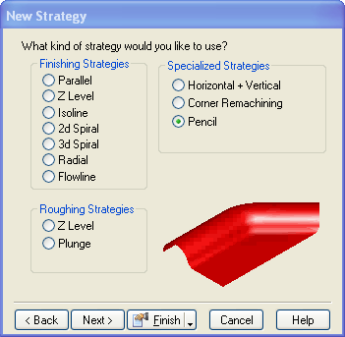

- Edit the feature by either double clicking on it in the graphics window, or right clicking on the feature name in the Part View and selecting Properties from the drop down menu.
- Click on Finish1 in the tree view and select a 10 mm ball endmill in the Tools tab.
- Simulate the toolpaths.

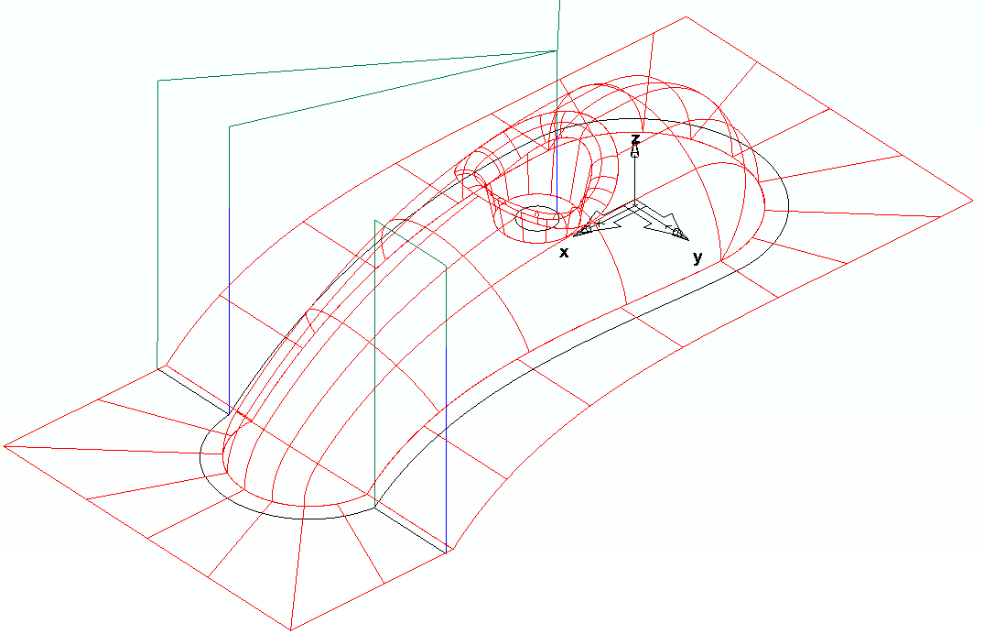

- Edit the feature.
- Click on Pencil in the tree view and click on the Slopes tab.
- On the Slopes tab, Click Horizontal only and set the Maximum surface slope to 30.

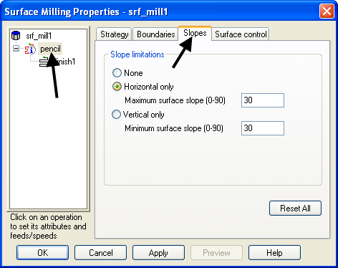

- Click OK and simulate the toolpaths.

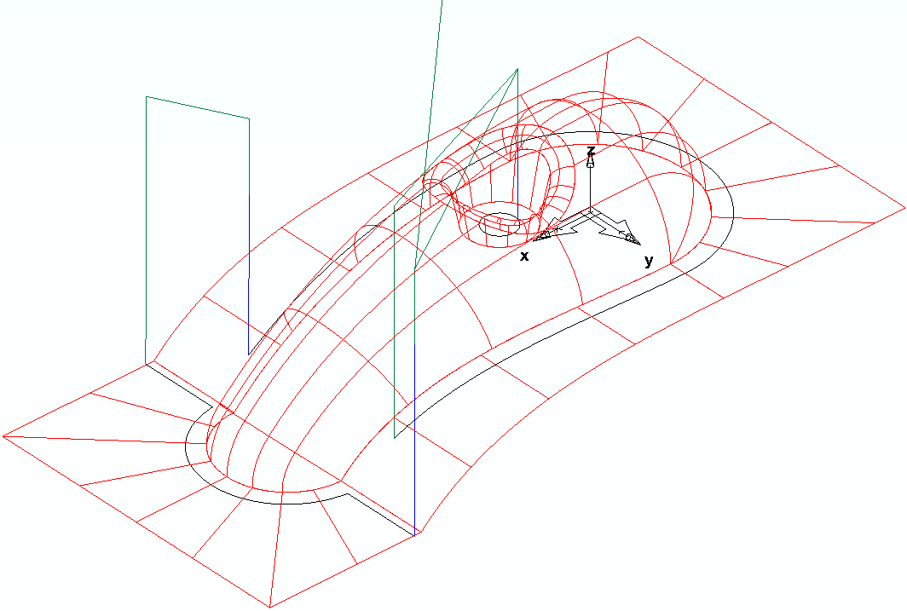

The toolpath is produced. The steep area is no longer machined.

- Edit the feature again.
- Click on Pencil in the tree view and click on the Slopes tab.
- Click Vertical only and set the Minimum surface slope to 30.
- Simulate the toolpaths.
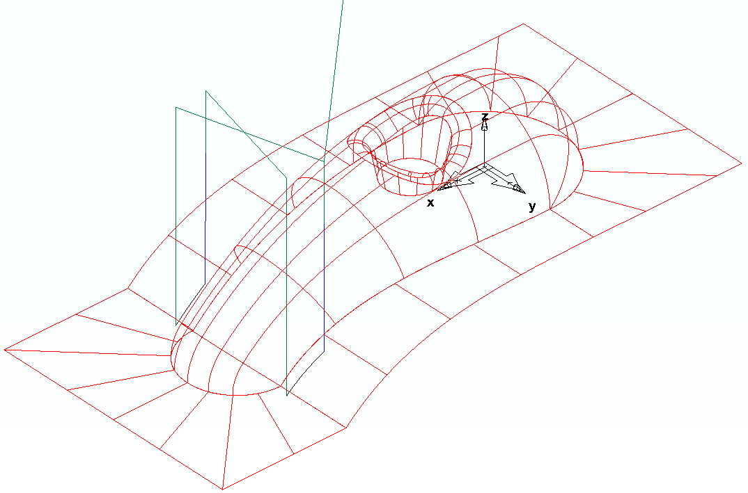

Now only the steep area is machined.

- Uncheck the surface milling feature named srf_mill1 in the Part View.

Corner Along Finishing

All the Corner Finishing strategies, (except for Pencil) are based on machining the area between the Previous tool (2) and the Active tool (1).

In this example the main finishing tool is a 10 Ball nose (reference) to be Corner finished with a diameter 5 Ball-nose.

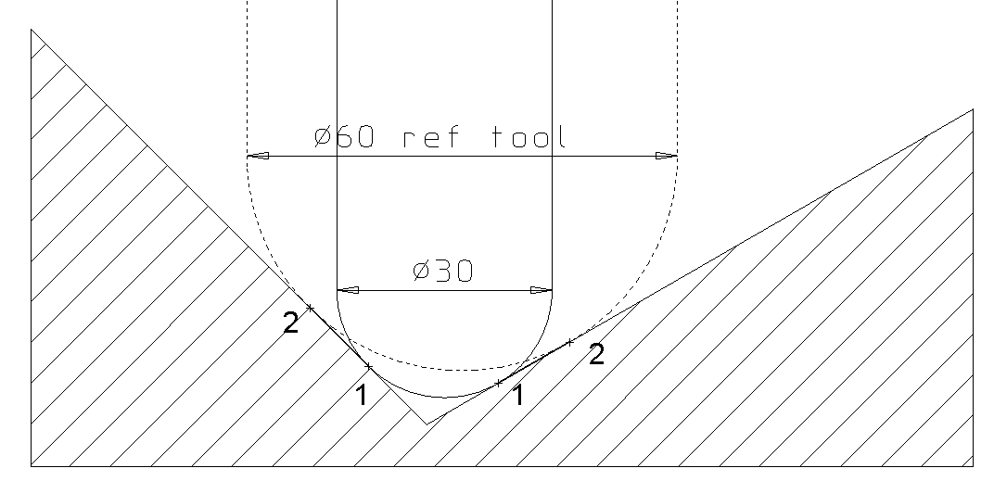

- Create a new feature from the same surfaces using the procedure listed above. When you reach the New Strategy tab, select Corner Remachining and click Next.
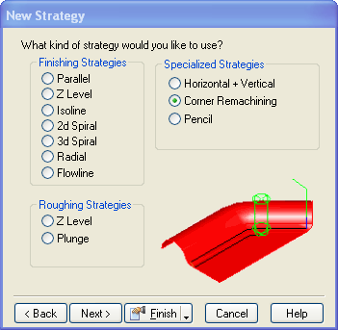

- Click Along and set the Previous tool diameter to 10. Click Finish.
- Edit the feature. Click on Remachine in the tree view.
- On the Slopes tab, Click Horizontal only and set the Maximum surface slope to 30.
- Click on finish1 in the tree view.
- Click on the Tools tab and select a 5 mm ball endmill.
- Click OK and simulate the toolpaths.
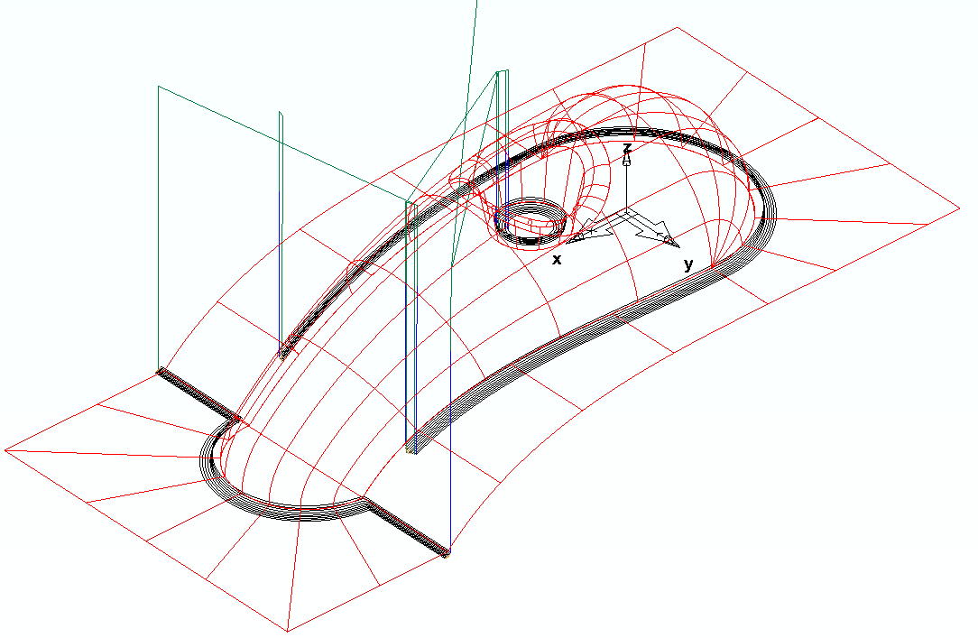

Note that it has machined the shallow areas from outside to inwards in a Climb milling direction.

The leads and links need to be improved

- Edit the feature.
- Click on Finish1 in the tree view and click on the Leads tab.
- Change Use lead-in/out to On all stepovers, plunges & retracts.
- Click Use arc ramp-in/out.
- Click OK and simulate the toolpaths.
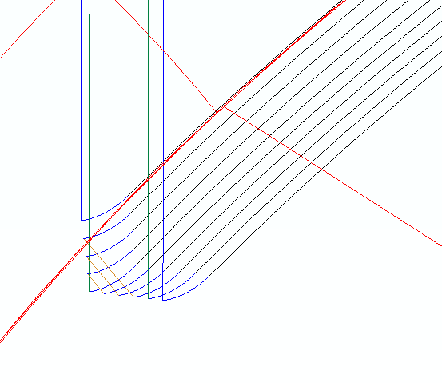

The arc lead provides a smoother transition onto the work piece with the tool already moving at the specified cutting feed rate.

Corner Across Finishing

- Edit the srf_mill2 feature.
- Click on Remachine in the part view and select Across as the Option.
- Click on Slopes tab and Select Vertical only and enter a Minimum surface slope of 30.
- Change edge boundary to Internal Only & press apply
- Click OK and simulate the toolpath.
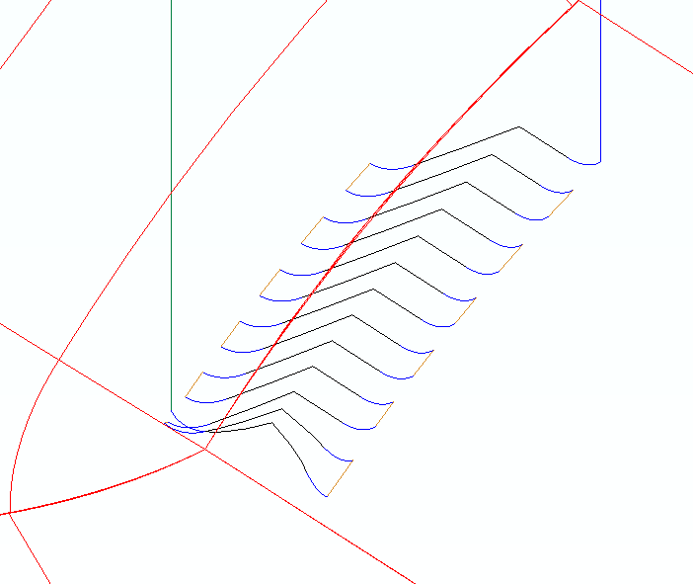

By picking out the steep areas with an Across strategy the tool loading is reduced giving a good surface finish with a smaller risk of tool damage.

Let’s now change the stepovers to be smoother.

- Edit the srf_mill2 feature.
- Click on Finish1 in the part view and click on the Leads tab.
- Select Loop as the Stepover type.
- Click OK and simulate toolpaths.

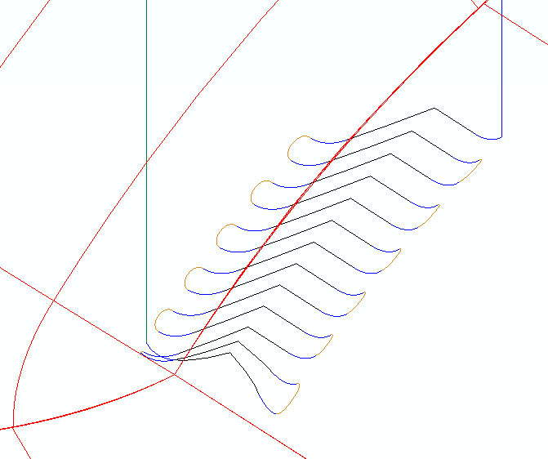

Note how the ends of the cutting moves are now connected by a loop link giving a smooth progression of the cutting tool onto and off the job.

Combo Along and Across Corner Finishing

- Edit the srf_mill2 feature.
- Click on Remachine in the part view and select Combo Along and Across as the Option.
- On the Slopes tab, Click None.
- Click OK and simulate the toolpaths.
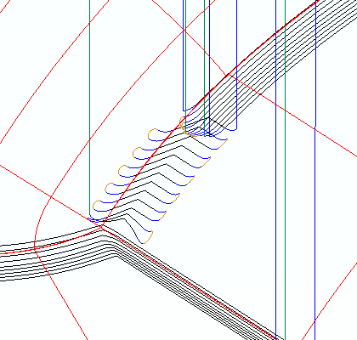

This has machined the shallow areas using an Along strategy and the steep areas using Across. This gives the optimum surface finish whilst protecting the tool in steep areas.

Corner Multi Pencil Finishing

- Edit the srf_mill2 feature.
- Click on Remachine in the part view and select Multi pencil as the Option.
- On the Slopes tab, Click Horizontal only and set the Maximum surface slope to 30.
- Click OK and simulate the toolpaths.
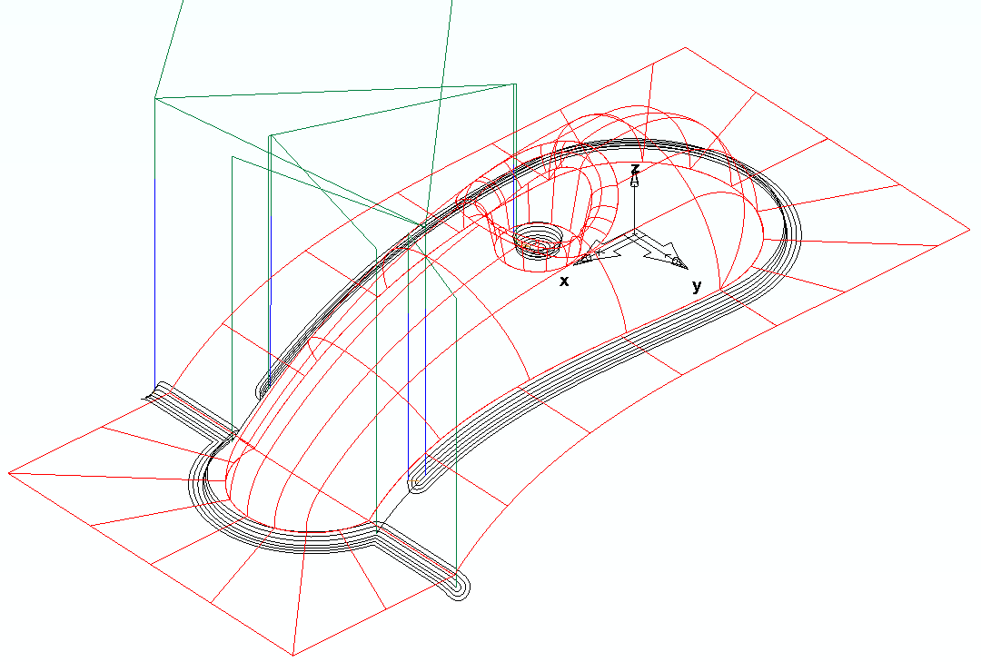
This toolpath is similar to the Along strategy except that it doesn’t lift off the job as much. The only disadvantage is that it alternates between climb and conventional milling.

